Data Structures in C Lab File
1.
#include <stdio.h>
#define MAX 100 // Maximum size of the array
void display(int arr[], int n) {
if (n == 0) {
printf("Array is empty.\n");
} else {
printf("Current Array: ");
for (int i = 0; i < n; i++) {
printf("%d ", arr[i]);
}
printf("\n");
}
}
int insert(int arr[], int n, int element, int position) {
if (n >= MAX) {
printf("Array is full. Cannot insert.\n");
return n;
}
if (position < 0 || position > n) {
printf("Invalid position!\n");
return n;
}
// Shift elements to the right
for (int i = n; i > position; i--) {
arr[i] = arr[i - 1];
}
arr[position] = element;
printf("Inserted %d at position %d.\n", element, position);
return n + 1;
}
int delete(int arr[], int n, int element) {
int pos = -1;
for (int i = 0; i < n; i++) {
if (arr[i] == element) {
pos = i;
break;
}
}
if (pos == -1) {
printf("Element %d not found in the array.\n", element);
return n;
}
// Shift elements to the left
for (int i = pos; i < n - 1; i++) {
arr[i] = arr[i + 1];
}
printf("Deleted %d from the array.\n", element);
return n - 1;
}
int main() {
int arr[MAX];
int n = 0; // Current size of the array
int choice, element, position;
while (1) {
printf("\n--- Array Operations Menu ---\n");
printf("1. Insert\n");
printf("2. Delete\n");
printf("3. Display\n");
printf("4. Exit\n");
printf("Enter your choice: ");
scanf("%d", &choice);
switch (choice) {
case 1:
printf("Enter element to insert: ");
scanf("%d", &element);
printf("Enter position (0 to %d): ", n);
scanf("%d", &position);
n = insert(arr, n, element, position);
break;
case 2:
printf("Enter element to delete: ");
scanf("%d", &element);
n = delete(arr, n, element);
break;
case 3:
display(arr, n);
break;
case 4:
printf("Exiting program...\n");
return 0;
default:
printf("Invalid choice! Please try again.\n");
}
}
}
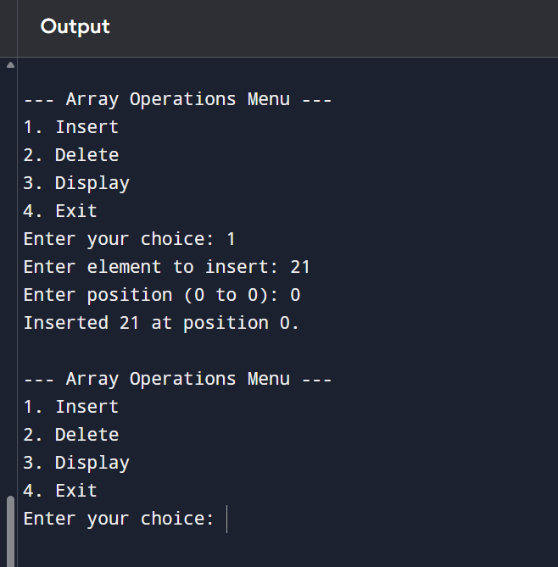

2. #include <stdio.h>
#define MAX 10 // Maximum size of matrix
void inputMatrix(int mat[MAX][MAX], int rows, int cols) {
printf("Enter elements of the matrix (%d x %d):\n", rows, cols);
for (int i = 0; i < rows; i++) {
for (int j = 0; j < cols; j++) {
scanf("%d", &mat[i][j]);
}
}
}
void displayMatrix(int mat[MAX][MAX], int rows, int cols) {
printf("Matrix (%d x %d):\n", rows, cols);
for (int i = 0; i < rows; i++) {
for (int j = 0; j < cols; j++) {
printf("%d\t", mat[i][j]);
}
printf("\n");
}
}
void addMatrix(int A[MAX][MAX], int B[MAX][MAX], int rows, int cols) {
int C[MAX][MAX];
for (int i = 0; i < rows; i++) {
for (int j = 0; j < cols; j++) {
C[i][j] = A[i][j] + B[i][j];
}
}
printf("Sum of matrices:\n");
displayMatrix(C, rows, cols);
}
void subtractMatrix(int A[MAX][MAX], int B[MAX][MAX], int rows, int cols) {
int C[MAX][MAX];
for (int i = 0; i < rows; i++) {
for (int j = 0; j < cols; j++) {
C[i][j] = A[i][j] - B[i][j];
}
}
printf("Subtraction of matrices (A - B):\n");
displayMatrix(C, rows, cols);
}
void multiplyMatrix(int A[MAX][MAX], int B[MAX][MAX], int r1, int c1, int r2, int c2) {
if (c1 != r2) {
printf("Matrix multiplication not possible (columns of A != rows of B).\n");
return;
}
int C[MAX][MAX];
for (int i = 0; i < r1; i++) {
for (int j = 0; j < c2; j++) {
C[i][j] = 0;
for (int k = 0; k < c1; k++) {
C[i][j] += A[i][k] * B[k][j];
}
}
}
printf("Product of matrices:\n");
displayMatrix(C, r1, c2);
}
void transposeMatrix(int A[MAX][MAX], int rows, int cols) {
int T[MAX][MAX];
for (int i = 0; i < rows; i++) {
for (int j = 0; j < cols; j++) {
T[j][i] = A[i][j];
}
}
printf("Transpose of matrix:\n");
displayMatrix(T, cols, rows);
}
int main() {
int A[MAX][MAX], B[MAX][MAX];
int r1, c1, r2, c2;
int choice;
printf("Enter rows and columns of Matrix A: ");
scanf("%d %d", &r1, &c1);
inputMatrix(A, r1, c1);
printf("Enter rows and columns of Matrix B: ");
scanf("%d %d", &r2, &c2);
inputMatrix(B, r2, c2);

while (1) {
printf("\n--- Matrix Operations Menu ---\n");
printf("1. Sum of matrices\n");
printf("2. Subtraction of matrices\n");
printf("3. Product of matrices\n");
printf("4. Transpose of Matrix A\n");
printf("5. Transpose of Matrix B\n");
printf("6. Exit\n");
printf("Enter your choice: ");
scanf("%d", &choice);
switch (choice) {
case 1:
if (r1 == r2 && c1 == c2)
addMatrix(A, B, r1, c1);
else
printf("Addition not possible (matrices must be same size).\n");
break;
case 2:
if (r1 == r2 && c1 == c2)
subtractMatrix(A, B, r1, c1);
else
printf("Subtraction not possible (matrices must be same size).\n");
break;
case 3:
multiplyMatrix(A, B, r1, c1, r2, c2);
break;
case 4:
transposeMatrix(A, r1, c1);
break;
case 5:
transposeMatrix(B, r2, c2);
break;
case 6:
printf("Exiting program...\n");
return 0;
default:
printf("Invalid choice! Try again.\n");
}
}
}
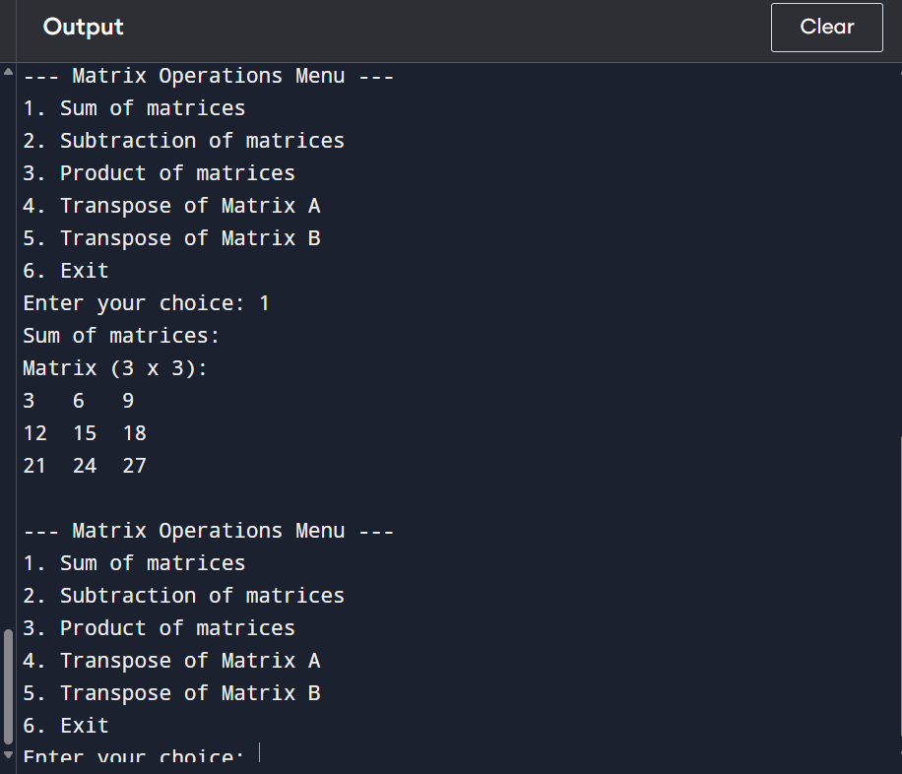
3. #include <stdio.h>
#define MAX 100
// Function to print array
void printArray(int arr[], int n) {
for(int i = 0; i < n; i++)
printf("%d ", arr[i]);
printf("\n");
}
void bubbleSort(int arr[], int n) {
for(int i = 0; i < n-1; i++) {
for(int j = 0; j < n-i-1; j++) {
if(arr[j] > arr[j+1]) {
int temp = arr[j];
arr[j] = arr[j+1];
arr[j+1] = temp;
}
}
}
}
void insertionSort(int arr[], int n) {
for(int i = 1; i < n; i++) {
int key = arr[i];
int j = i - 1;
while(j >= 0 && arr[j] > key) {
arr[j+1] = arr[j];
j--;
}
arr[j+1] = key;
}
}
int partition(int arr[], int low, int high) {
int pivot = arr[high];
int i = low - 1;
for(int j = low; j < high; j++) {
if(arr[j] < pivot) {
i++;
int temp = arr[i];
arr[i] = arr[j];
arr[j] = temp;
}
}
int temp = arr[i+1];
arr[i+1] = arr[high];
arr[high] = temp;
return i + 1;
}
void quickSort(int arr[], int low, int high) {
if(low < high) {
int pi = partition(arr, low, high);
quickSort(arr, low, pi - 1);
quickSort(arr, pi + 1, high);
}
}
void merge(int arr[], int l, int m, int r) {
int i = l, j = m + 1, k = 0;
int temp[MAX];
while(i <= m && j <= r) {
if(arr[i] <= arr[j])
temp[k++] = arr[i++];
else
temp[k++] = arr[j++];
}
while(i <= m)
temp[k++] = arr[i++];
while(j <= r)
temp[k++] = arr[j++];
for(i = l, j = 0; i <= r; i++, j++)
arr[i] = temp[j];
}
void mergeSort(int arr[], int l, int r) {
if(l < r) {
int m = (l + r) / 2;
mergeSort(arr, l, m);
mergeSort(arr, m + 1, r);
merge(arr, l, m, r);
}
}
/* ---------------- Heap Sort ---------------- */
void heapify(int arr[], int n, int i) {
int largest = i;
int left = 2*i + 1;
int right = 2*i + 2;
if(left < n && arr[left] > arr[largest])
largest = left;
if(right < n && arr[right] > arr[largest])
largest = right;
if(largest != i) {
int temp = arr[i];
arr[i] = arr[largest];
arr[largest] = temp;
heapify(arr, n, largest);
}
}
void heapSort(int arr[], int n) {
for(int i = n/2 - 1; i >= 0; i--)
heapify(arr, n, i);
for(int i = n-1; i >= 0; i--) {
int temp = arr[0];
arr[0] = arr[i];
arr[i] = temp;
heapify(arr, i, 0);
}
}
/* ---------------- Main Function ---------------- */
int main() {
int arr[] = {25, 12, 22, 11, 90, 34, 2};
int n = sizeof(arr)/sizeof(arr[0]);
int temp[MAX];
printf("Original Array:\n");
printArray(arr, n);
// Bubble Sort
for(int i=0;i<n;i++) temp[i]=arr[i];
bubbleSort(temp, n);
printf("\nBubble Sorted Array:\n");
printArray(temp, n);
// Insertion Sort
for(int i=0;i<n;i++) temp[i]=arr[i];
insertionSort(temp, n);
printf("\nInsertion Sorted Array:\n");
printArray(temp, n);
// Quick Sort
for(int i=0;i<n;i++) temp[i]=arr[i];
quickSort(temp, 0, n-1);
printf("\nQuick Sorted Array:\n");
printArray(temp, n);
// Merge Sort
for(int i=0;i<n;i++) temp[i]=arr[i];
mergeSort(temp, 0, n-1);
printf("\nMerge Sorted Array:\n");
printArray(temp, n);
// Heap Sort
for(int i=0;i<n;i++) temp[i]=arr[i];
heapSort(temp, n);
printf("\nHeap Sorted Array:\n");
printArray(temp, n);
return 0;
}

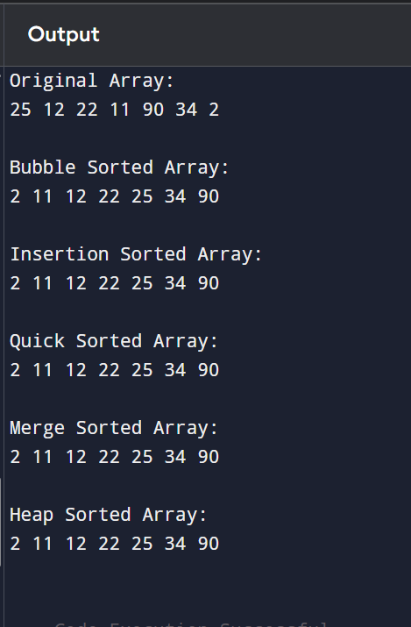

4. #include <stdio.h>
// Linear Search
int linearSearch(int arr[], int n, int key) {
for(int i = 0; i < n; i++) {
if(arr[i] == key)
return i; // element found
}
return -1; // element not found
}
// Binary Search
int binarySearch(int arr[], int low, int high, int key) {
while(low <= high) {
int mid = (low + high) / 2;

if(arr[mid] == key)
return mid;
else if(arr[mid] < key)
low = mid + 1;
else
high = mid - 1;
}
return -1;
}
int main() {
int arr[] = {2, 5, 8, 12, 16, 23, 38};
int n = sizeof(arr) / sizeof(arr[0]);
int key;
printf("Enter element to search: ");
scanf("%d", &key);
// Linear Search
int result1 = linearSearch(arr, n, key);
if(result1 != -1)
printf("Element found using Linear Search at index %d\n", result1);
else
printf("Element not found using Linear Search\n");

// Binary Search
int result2 = binarySearch(arr, 0, n-1, key);
if(result2 != -1)
printf("Element found using Binary Search at index %d\n", result2);
else
printf("Element not found using Binary Search\n");
return 0;
}
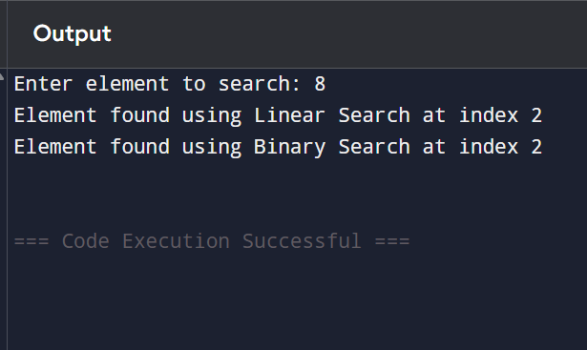
5. Stack Operations
#include <stdio.h>
#define MAX 5
int stack[MAX];
int top = -1;
/* Function to push element into stack */
void push() {
int value;
if (top == MAX - 1) {
printf("Stack Overflow! Cannot insert element.\n");
} else {
printf("Enter value to push: ");
scanf("%d", &value);
top++;
stack[top] = value;
printf("%d pushed into stack successfully.\n", value);
}
}
/* Function to pop element from stack */
void pop() {
if (top == -1) {
printf("Stack Underflow! Stack is empty.\n");
} else {
printf("%d popped from stack.\n", stack[top]);
top--;
}
}
/* Function to peek top element */
void peek() {
if (top == -1) {
printf("Stack is empty. No top element.\n");
} else {
printf("Top element is: %d\n", stack[top]);
}
}
/* Function to display stack elements */
void display() {
int i;
if (top == -1) {
printf("Stack is empty.\n");
} else {
printf("Stack elements are:\n");
for (i = top; i >= 0; i--) {
printf("%d\n", stack[i]);
}
}
}
int main() {
int choice;
do {
printf("\n--- STACK MENU ---\n");
printf("1. Push\n");
printf("2. Pop\n");
printf("3. Peek\n");
printf("4. Display\n");
printf("5. Exit\n");
printf("Enter your choice: ");
scanf("%d", &choice);
switch (choice) {
case 1:
push();
break;
case 2:
pop();
break;
case 3:
peek();
break;
case 4:
display();
break;
case 5:
printf("Exiting program.\n");
break;
default:
printf("Invalid choice! Please try again.\n");
}
} while (choice != 5);
return 0;
}
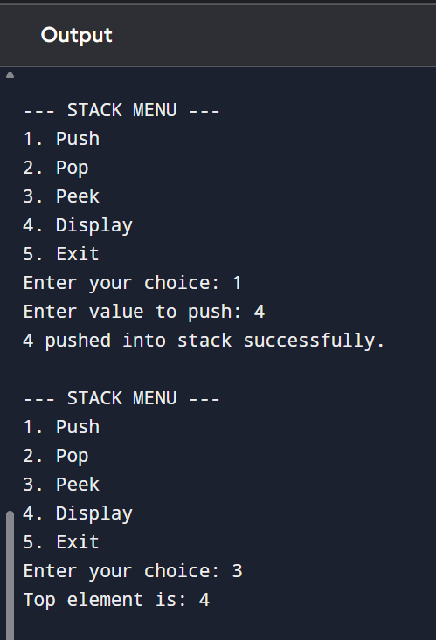

6. #include <stdio.h>
#include <ctype.h>
int stack[100];
int top = -1;
void push(int x)
{
stack[++top] = x;
}
int pop()
{
return stack[top--];
}
int main()
{
char postfix[100];
int i, op1, op2, result;
printf("Enter postfix expression: ");
scanf("%s", postfix);
for(i = 0; postfix[i] != '\0'; i++)
{
if(isdigit(postfix[i]))
{
push(postfix[i] - '0');
}
else
{
op2 = pop();
op1 = pop();
switch(postfix[i])
{
case '+': push(op1 + op2); break;
case '-': push(op1 - op2); break;
case '*': push(op1 * op2); break;
case '/': push(op1 / op2); break;
}
}
}
result = pop();
printf("Result = %d", result);
return 0;
}
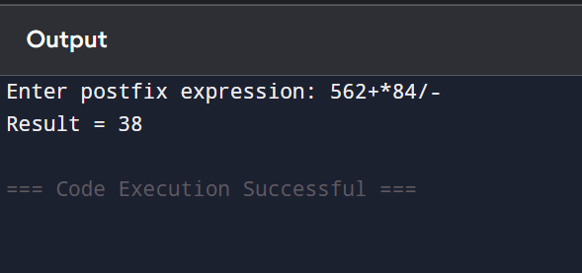
7. #include <stdio.h>
#include <ctype.h>
char stack[100];
int top = -1;
void push(char x)
{
stack[++top] = x;
}
char pop()
{
return stack[top--];
}
int precedence(char x)
{
if(x == '+' || x == '-') return 1;
if(x == '*' || x == '/') return 2;
return 0;
}
int main()
{
char infix[100], postfix[100];
int i, j = 0;
char x;
printf("Enter infix expression: ");
scanf("%s", infix);
for(i = 0; infix[i] != '\0'; i++)
{
if(isalnum(infix[i]))
{
postfix[j++] = infix[i];
}
else if(infix[i] == '(')
{
push(infix[i]);
}
else if(infix[i] == ')')
{
while((x = pop()) != '(')
{
postfix[j++] = x;
}
}
else
{
while(top != -1 && precedence(stack[top]) >= precedence(infix[i]))
{
postfix[j++] = pop();
}
push(infix[i]);
}
}
while(top != -1)
{
postfix[j++] = pop();
}
postfix[j] = '\0';
printf("Postfix Expression: %s", postfix);
return 0;
}
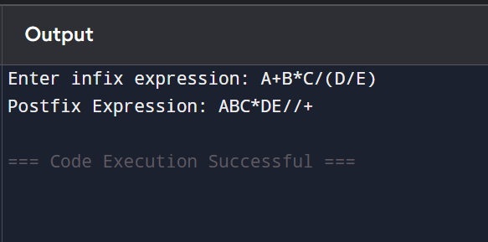
8. #include <stdio.h>
#include <stdlib.h>
// Define structure
struct Node {
int data;
struct Node* next;
};
struct Node* head = NULL;
// Insert at beginning
void insertBegin(int value) {
struct Node* newNode = (struct Node*)malloc(sizeof(struct Node));
newNode->data = value;
newNode->next = head;
head = newNode;
}
// Delete a node
void deleteNode(int key) {
struct Node *temp = head, *prev = NULL;
// If head node holds the value
if (temp != NULL && temp->data == key) {
head = temp->next;
free(temp);
return;
}
// Search for the key
while (temp != NULL && temp->data != key) {
prev = temp;
temp = temp->next;
}
// If key not found
if (temp == NULL) {
printf("Element not found\n");
return;
}
// Unlink the node
prev->next = temp->next;
free(temp);
}
// Display linked list
void display() {
struct Node* temp = head;
while (temp != NULL) {
printf("%d -> ", temp->data);
temp = temp->next;
}
printf("NULL\n");
}
int main() {
insertBegin(30);
insertBegin(20);
insertBegin(10);
printf("Linked List after insertion:\n");
display();
deleteNode(20);
printf("Linked List after deletion:\n");
display();
return 0;
}
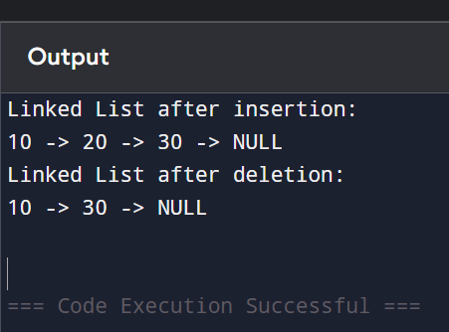
9. #include <stdio.h>
#include <stdlib.h>
struct Node {
int data;
struct Node* next;
};
struct Node* head = NULL;
// Insertion
void insert(int value) {
struct Node* newNode = (struct Node*)malloc(sizeof(struct Node));
newNode->data = value;
if (head == NULL) {
head = newNode;
newNode->next = head;
}
else {
struct Node* temp = head;
while (temp->next != head) {
temp = temp->next;
}
temp->next = newNode;
newNode->next = head;
}
}
// Deletion
void delete(int key) {
struct Node *temp = head, *prev;

if (head == NULL) {
printf("List is empty\n");
return;
}
// If head node is to be deleted
if (head->data == key) {
while (temp->next != head)
temp = temp->next;
if (temp == head) {
free(head);
head = NULL;
}
else {
temp->next = head->next;
free(head);
head = temp->next;
}
return;
}
prev = head;
temp = head->next;
while (temp != head && temp->data != key) {
prev = temp;
temp = temp->next;
}
if (temp == head) {
printf("Element not found\n");
}
else {
prev->next = temp->next;
free(temp);
}
}
// Display
void display() {
if (head == NULL) {
printf("List is empty\n");
return;
}
struct Node* temp = head;
do {
printf("%d -> ", temp->data);
temp = temp->next;
} while (temp != head);
printf("(Back to Head)\n");
}
int main() {
insert(10);
insert(20);
insert(30);
printf("Circular Linked List:\n");
display();
delete(20);
printf("\nAfter Deletion:\n");
display();
return 0;
}
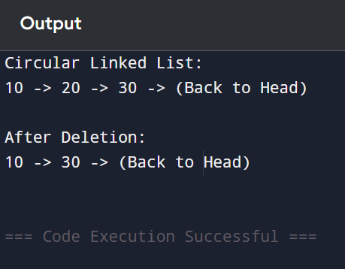
10. #include <stdio.h>
#include <stdlib.h>
struct Node {
int data;
struct Node* next;
};
/* ---------- STACK USING LINKED LIST ---------- */
struct Node* top = NULL;
void push(int value) {
struct Node* newNode = (struct Node*)malloc(sizeof(struct Node));
newNode->data = value;
newNode->next = top;
top = newNode;
}
void pop() {
if(top == NULL) {
printf("Stack Underflow\n");
return;
}
struct Node* temp = top;
printf("Popped element: %d\n", top->data);
top = top->next;
free(temp);
}
void displayStack() {
struct Node* temp = top;
printf("Stack: ");
while(temp != NULL) {
printf("%d ", temp->data);
temp = temp->next;
}
printf("\n");
}
/* ---------- QUEUE USING LINKED LIST ---------- */
struct Node *front = NULL, *rear = NULL;
void enqueue(int value) {
struct Node* newNode = (struct Node*)malloc(sizeof(struct Node));
newNode->data = value;
newNode->next = NULL;

if(rear == NULL) {
front = rear = newNode;
return;
}
rear->next = newNode;
rear = newNode;
}
void dequeue() {
if(front == NULL) {
printf("Queue Underflow\n");
return;
}
struct Node* temp = front;
printf("Dequeued element: %d\n", front->data);
front = front->next;
if(front == NULL)
rear = NULL;
free(temp);
}
void displayQueue() {
struct Node* temp = front;
printf("Queue: ");
while(temp != NULL) {
printf("%d ", temp->data);
temp = temp->next;
}
printf("\n");
}
/* ---------- CIRCULAR QUEUE USING LINKED LIST ---------- */
struct Node *cfront = NULL, *crear = NULL;
void insertCQ(int value) {
struct Node* newNode = (struct Node*)malloc(sizeof(struct Node));
newNode->data = value;
if(cfront == NULL) {
cfront = crear = newNode;
newNode->next = cfront;
}
else {
crear->next = newNode;
crear = newNode;
crear->next = cfront;
}
}
void deleteCQ() {
if(cfront == NULL) {
printf("Circular Queue Underflow\n");
return;
}
struct Node* temp = cfront;
printf("Deleted element: %d\n", temp->data);
if(cfront == crear) {
cfront = crear = NULL;
}
else {
cfront = cfront->next;
crear->next = cfront;
}
free(temp);
}
void displayCQ() {
if(cfront == NULL) {
printf("Circular Queue is empty\n");
return;
}
struct Node* temp = cfront;
printf("Circular Queue: ");
do {
printf("%d ", temp->data);
temp = temp->next;
} while(temp != cfront);
printf("\n");
}
/* ---------- MAIN FUNCTION ---------- */
int main() {
/* Stack Operations */
push(10);
push(20);
push(30);
displayStack();
pop();
displayStack();
printf("\n");
/* Queue Operations */
enqueue(5);
enqueue(15);
enqueue(25);
displayQueue();
dequeue();
displayQueue();
printf("\n");
/* Circular Queue Operations */
insertCQ(1);
insertCQ(2);
insertCQ(3);
displayCQ();
deleteCQ();
displayCQ();
return 0;
}
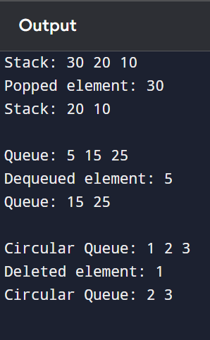

11.#include <stdio.h>
#include <stdlib.h>
// Define structure
struct node {
int data;
struct node *next;
};
// Function to create a new node
struct node* createNode(int value) {
struct node* newNode = (struct node*)malloc(sizeof(struct node));
newNode->data = value;
newNode->next = NULL;
return newNode;
}
// Function to insert at end
struct node* insertEnd(struct node* head, int value) {
struct node* newNode = createNode(value);
if (head == NULL)
return newNode;
struct node* temp = head;
while (temp->next != NULL)
temp = temp->next;
temp->next = newNode;
return head;
}
// Function to concatenate two lists
struct node* concatenate(struct node* head1, struct node* head2) {
if (head1 == NULL)
return head2;
struct node* temp = head1;
while (temp->next != NULL)
temp = temp->next;
temp->next = head2;
return head1;
}
// Function to display list
void display(struct node* head) {
struct node* temp = head;
while (temp != NULL) {
printf("%d -> ", temp->data);
temp = temp->next;
}
printf("NULL\n");
}
// Main function
int main() {
struct node *list1 = NULL, *list2 = NULL, *result = NULL;
// Creating first list
list1 = insertEnd(list1, 1);
list1 = insertEnd(list1, 2);
list1 = insertEnd(list1, 3);
// Creating second list
list2 = insertEnd(list2, 4);
list2 = insertEnd(list2, 5);
list2 = insertEnd(list2, 6);
printf("List 1: ");
display(list1);
printf("List 2: ");
display(list2);
// Concatenation
result = concatenate(list1, list2);
printf("After Concatenation: ");
display(result);
return 0;
}
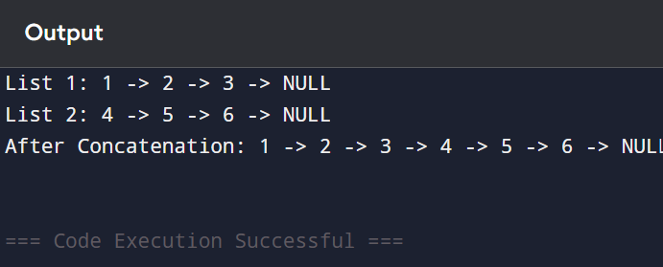

18. #include <stdio.h>
#include <stdlib.h>
#include <string.h>
#define MAX 5
#define NAME_LENGTH 50
char queue[MAX][NAME_LENGTH];
int front = -1;
int rear = -1;
// Check if queue is full
int isFull() {
return (rear + 1) % MAX == front;
}
// Check if queue is empty
int isEmpty() {
return front == -1;
}
// Add patient (Enqueue)
void addPatient() {
if (isFull()) {
printf("\nQueue is full! Cannot add more patients.\n");
return;
}
char name[NAME_LENGTH];
printf("Enter patient name: ");
scanf(" %[^\n]", name);
if (isEmpty()) {
front = rear = 0;
} else {
rear = (rear + 1) % MAX;
}
strcpy(queue[rear], name);
printf("Patient %s added successfully.\n", name);
}
// View next patient (Peek)
void viewNextPatient() {
if (isEmpty()) {
printf("\nNo patients waiting.\n");
return;
}
printf("\nNext patient: %s\n", queue[front]);
}
// Serve patient (Dequeue)
void servePatient() {
if (isEmpty()) {
printf("\nNo patients to serve.\n");
return;
}
printf("\nPatient %s has been served.\n", queue[front]);
if (front == rear) {
front = rear = -1; // Queue becomes empty
} else {
front = (front + 1) % MAX;
}
}
// Display all waiting patients
void displayPatients() {
if (isEmpty()) {
printf("\nNo patients in queue.\n");
return;
}
printf("\nWaiting Patients:\n");
int i = front;
while (1) {
printf("- %s\n", queue[i]);
if (i == rear)
break;
i = (i + 1) % MAX;
}
}
// Main function
int main() {
int choice;
do {
printf("\n===== Clinic Appointment System =====\n");
printf("1. Add Patient\n");
printf("2. View Next Patient\n");
printf("3. Serve Patient\n");
printf("4. Display All Patients\n");
printf("5. Exit\n");
printf("Enter your choice: ");
scanf("%d", &choice);
switch (choice) {
case 1:
addPatient();
break;
case 2:
viewNextPatient();
break;
case 3:
servePatient();
break;
case 4:
displayPatients();
break;
case 5:
printf("\nExiting system...\n");
break;
default:
printf("\nInvalid choice! Try again.\n");
}
} while (choice != 5);
return 0;
}

Tree traversal
PREORDER
Step 1: Check if root ≠ NULL
Step 2: If true, perform the following steps:
- Visit the root node (print the data)
print(root->data)
- Traverse the left subtree
display(root->left)
- Traverse the right subtree
display(root->right)
Step 6: Stop when root = NULL
Step 7: End
INORDER
Step 1: Start
Step 2: Check if root = NULL
If true, return.
Step 3: Traverse the left subtree
inorder(root->left)
Step 4: Visit the root node
print(root->data)
Step 5: Traverse the right subtree
inorder(root->right)
Step 6: End
Post Order
Step 1: Start
Step 2: Check if root = NULL
If true, return.
Step 3: Traverse the left subtree
Step 4: Traverse the right subtree
Step 5: Visit the root node
Step 6: End

